New Mexico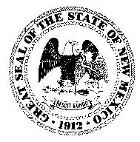
Public Education Department
300 Don Gaspar
Santa Fe, New Mexico 87501-2786
www.ped.state.nm.us
Mariana padilla
Secretary of Education

Public Notice
For Immediate Release: March 5, 2025

Black Education Act Advisory Council Schedules Meeting for March 8, 2025

SANTA FE – The Black Education Act Advisory Council will hold its regular meeting on Saturday, March 8, 2025 beginning at 9:00 a.m.

.32The meeting will take place through virtual format. Meeting link and the BEA Advisory Council meeting agenda (below) for members of the public to access the work session and the meeting.

To attend the BEA Advisory Council meeting virtually, click the link below.

Location: Teams Join the meeting now Meeting ID: 232 356 986 977
Passcode: iv7So6gP +

AGENDA LINK: https://docs.google.com/document/d/1DwDzjX2jg9bFomVKMnV8N47YsDD9WBOf/edit?usp=drive_link&ouid=115473741723766006899&rtpof=true&sd=true

###

